Virtual presentation of Roman Heritage in the Balkans

The goal of the Roman Heritage in the Balkans project is to create a virtual presentation of Roman cultural monuments in Bosnia and Herzegovina, Serbia, Montenegro and Albania showing that the whole area had common cultural heritage. Roman villa and terme in Ilidza near Sarajevo, Roman military camp and city Viminacium near Pozarevac, Serbia, Municipium settlement near Pljevlja, Montenegro and Durres amphitheater in Albania is presented through VR storytelling within an application available online and installed in local museums, close to the selected archaeological sites. It will enable the Internet users and museum visitors to take a virtual walk through Balkans in the Roman period and learn about monuments preserved only in fragments.
In the second version of the applications the users can virtually visit Butrint, Doclea, Mogorjelo and Lederata, and learn from storytelling of goddess Minerva and other historical characters about life in those places during the Roman Empire. After they see all stories and correctly answer the quiz questions, they can interact with selected exhibits found on locations and digitized through photogrammetry.

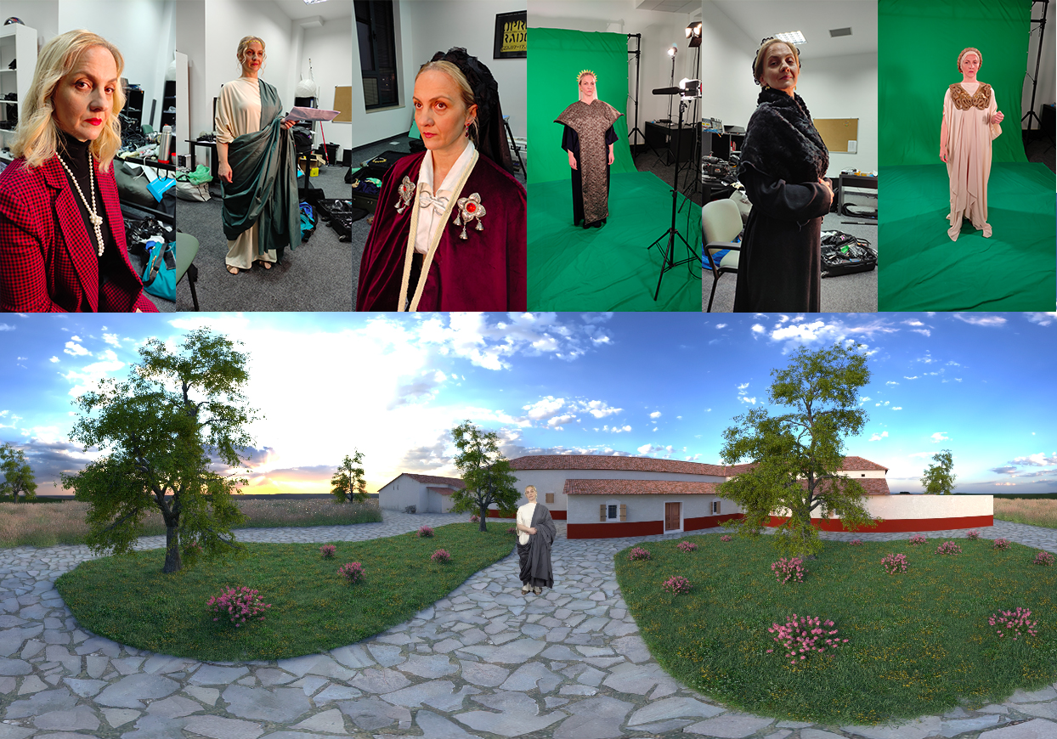

PROJECT TEAM: archaeologists Lida Miraj, Adnan Busuladžić, Nemanja Radunović, Mladen Jovičić and Nemanja Mrđić, architect Emilija Nikolić, art historian Jelena Anđelković Grašar, location consultant Dražen Karadaglić, scenario Fatmir Alispahić, music and sound design Adnan Mušanović, graphics design Mirsad Festa, Selma Rizvić, actress Selma Alispahić, costume design Adisa Vatreš Selimović, Monika Moćević, make-up Naida Đekić, camera Bojan Mijatović, programming Ivona Ivković Kihić, technical support Željko Jovanović, producer and Project coordinator Selma Rizvić

PROJECT PARTNERS: Udruženje za digitalizaciju i informatizaciju kulturne baštine DIGI.BA, Udruženje za promociju italijanske kulture u Bosni i Hercegovini „Dante Alighieri“, Bosnia and Herzegovina, UET CENTRE Albania, Arheološki Institut Beograd, Serbia and Montenergy Association, Montenegro

Web site of the project:
http://h.etf.unsa.ba/romanheritage/

Link to trailer video:
https://youtu.be/0MFdtb1yMes

Powered by:

