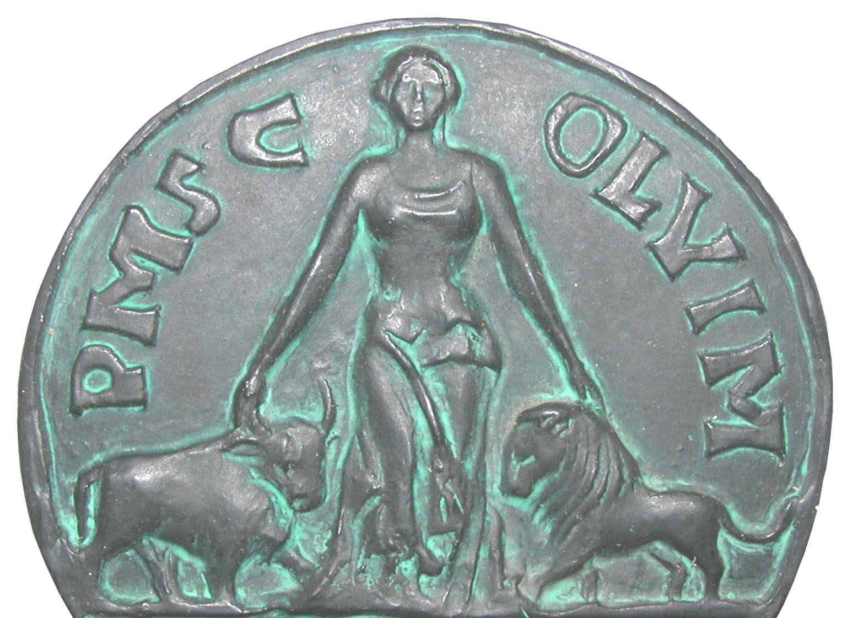
The 9th Joint Meeting of ECFN and nomisma.org
Organized by Institute of Archaeology, Belgrade
21st to 25th April 2020
REGISTRATION FORM
Name and Surname:

E-mail address:

Phone:

Institution:

Country:

Title of Presentation:

Abstract (up to 300 words):

Are you coming by plane or by car ? If you come by car please indicate where you will come and which day (see First Circular).

Will you go on the excursion ? By bus or with your own car ?

Do you have some special requests cosidering food ?

Participants are kindly requested to submit their registration before 1st November 2019
to the following address:
ECFNandNomisma.org2020@google.com

Contact:
Mirjana Vojvoda, Ph.D. Institute of Archaeology, Belgrade
E-mail. mirjana.vojvoda@gmail.com
Phone +381698098543

Institute of Archaeology
Knez Mihailova 35/IV
11.000 Belgrade, Serbia
http://www.ai.ac.rs
http://viminacium.org.rs/
institut@ai.ac.rs

